Ability Award 2024 Nomination Form
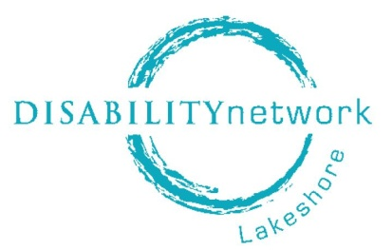
The Ability Award recognizes leaders in Allegan and Ottawa counties who promote a philosophy of independence and advocate for fully inclusive communities where people with disabilities can participate, contribute, and belong.

- Nominee Selection Criteria:
- LEADERSHIP: Demonstrates ability to motivate, inspire, and empower people or organizations that results in greater engagement and meaningful inclusion of people with disabilities.
- ADVOCACY: Demonstrates ability to champion the inclusion and independence of people with disabilities, in partnership with the disability community, through a program, project, or activity that results in systemic, structural, policy, or attitudinal change and increases the capacity of people with disabilities to live self-directed, independent lives.
- ENGAGEMENT: Demonstrates understanding for and prioritizes need to ensure that the unique gifts and talents of people with disabilities are fully realized so that people with disabilities feel fulfilled and know that their contribution matters (whether in their job, school, church, volunteer experiences, etc.).
- EMPOWERMENT: Creates opportunities for and with people with disabilities to increase independence and participate meaningfully in decision making; encourages people with disabilities to bring their lived experiences, personal autonomy and authority, vision, talents, and enthusiasm; and uses their personal power to open doors for people with disabilities to use theirs.
- LOCALE: Lives or works in Allegan or Ottawa counties.
- DISABILITY: Lives with a disability, has a family member with a disability, or is a friend or ally to the disability community.

(Disability Network Lakeshore board members and employees are not eligible for nomination.)

- Information about Ability Award nominee:
Name:
Address:
Telephone: Email:
Nominee’s area of interest or accomplishment:

- Information about you:
Name:
Address:
Telephone: Email:
Best time to reach you:

- Nomination rationale (essay):
In one sentence, describe your reason for nominating this individual:

In no more than 500 words (*see gray box below), please tell the story of the nominee’s efforts and achievements, including:
- How nominee demonstrates qualities of leadership, advocacy, engagement, and empowerment of people with disabilities; and,
- How nominee promotes a philosophy of independence, inclusion, and a community without barriers, regardless of ability.
*Answer here

Nomination deadline: March 4, 2024

Please notify your nominee of your nomination; DNL will follow up with each nominee.

Submit entries and direct questions to: Disability Network Lakeshore (info@dnlakeshore.org)

More information about the Ability Award is available at abilityaward.net

The Ability Award will be presented during a ceremony honoring all nominees on Tuesday evening, April 23, at Macatawa Golf Club in Holland.

